**Lecture 5**

* Continuing from last lecture (IBM Model 1)
  + Hidden variable $a$ (alignment, a one-to-one function)
 $p\left(f | e,a\right)=\prod_{j=1}^{n}{p(f_{j}|e_{j})}$

 $p\left(a | f,e,θ\right)=\frac{p\left(a,f | e\right)}{\sum_{a'}{p(a^{'},f|e)}}=\frac{p(a|e)p(f|a,e)}{\sum_{a'}{p(a^{'}|e)p(f|a^{'},e)}}=\frac{∏p(f_{j}|e_{a_{j}})}{∑p(f_{j}|e_{a_{j}})}$

  - Assume $p(a|e)$ uniform
  + Example
    - $e_{1}$: “b c”, $e_{2}:$“b”
    - $f_{1}$: “x y”, $f_{2}:$“y”
    - Initialize

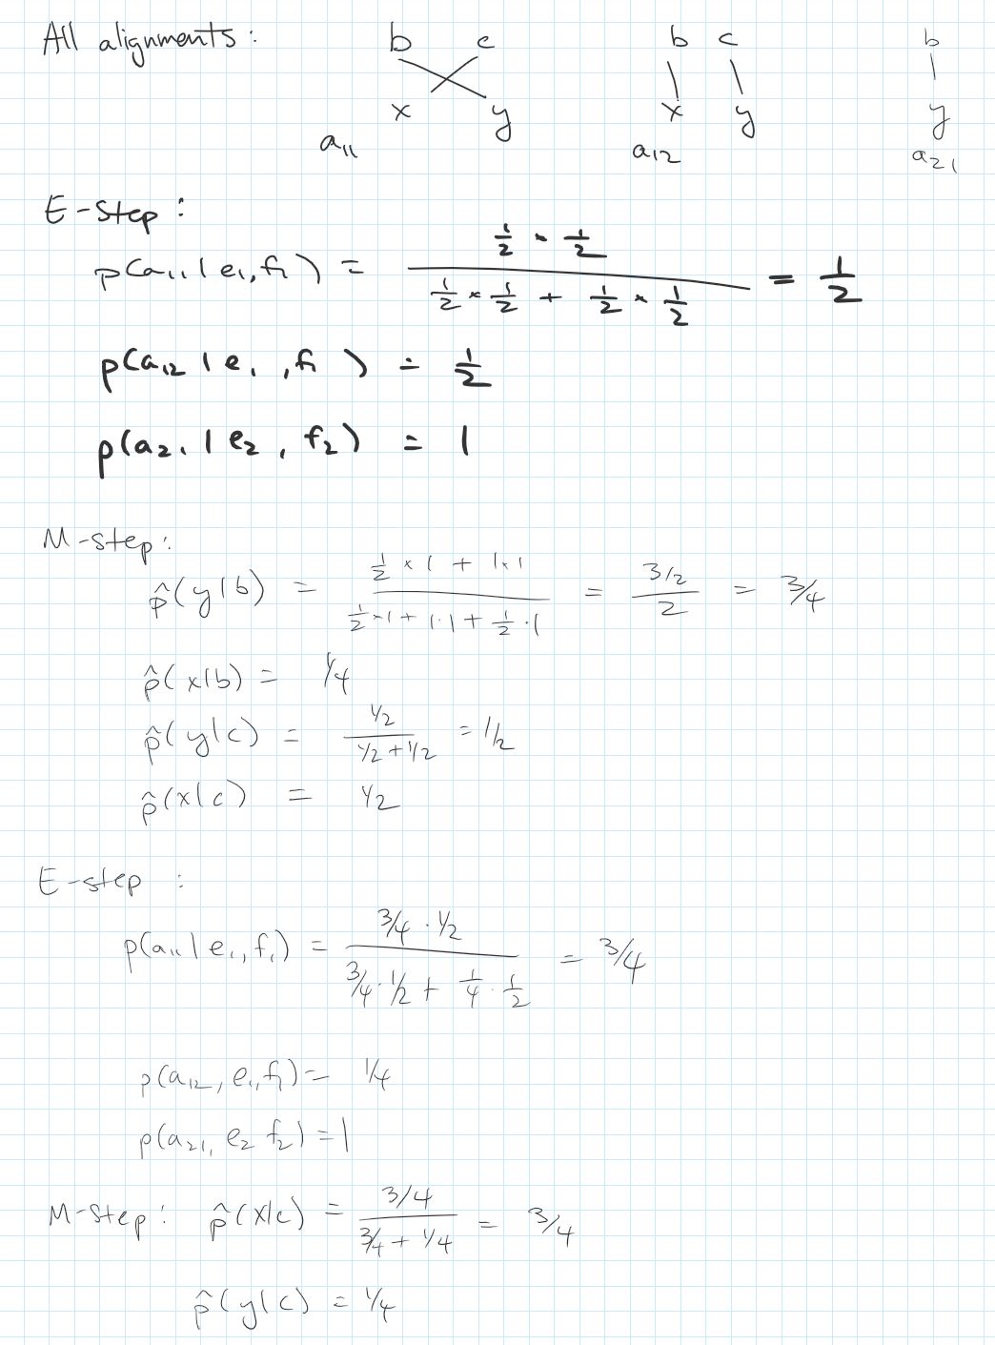



* Neural Models (We will be studying embeddings)
  + Review of neural models – refer to 6.036 lecture notes on Stellar
  + Huge impact on computer vision…not so much in NLP. Why?
    - Neural models do not really take into count the structure of language
    - Compared to previous models, neural models also need much more data
* Neural Language Models
  + Start with bigram model $p(w_{i}|w_{i-1})$

